

***MRCB* User Manual**



MRCB: An Open-Source Multi-system time-varying Receiver Code Bias Analysis Software

**Innovation Academy for Precision Measurement Science and Technology,**

**Chinese Academy of Sciences**©

Update: 2025.10

Contents

1 Overview 3

2 MRCB software 3

2.1 Structure of MRCB 3

2.2 Processing strategies 5

3 Requirements 6

3.1 Supported platforms 6

3.2 License 7

4 File structure 7

5 Configuration File (config.dat) 8

5.1 Input file configuration 8

5.2 Output file configuration 8

5.3 Processing strategies configuration 9

5.4 Station Information 10

6 Compile and Run 10

6.1 Compile 10

6.1.1 Windows 10

6.1.2 Linux 11

6.2 Run 12

6.2.1 day-by-day process 12

6.2.2 continuous processing 14

6.2.3 Linux Run 15

7 Output file format description 16

7.1 Result File 16

7.2 Process Information File 17

7.3 Log file 18

7.4 Execution Interface 19

Appendix 20

Acknowledgement 24

Contact author 24

References 24

# 1 Overview

Multi-system and Multi-frequency Receiver Code Bias Analysis Software (MRCB) is an open-source GNSS data processing package specifically designed for extracting time-varying receiver code biases (RCBs). MRCB is developed in C/C++, which can be easily ported to different operating systems, such as Windows and Linux. It is a post-processing software, which can process multi-frequency data from GPS, Galileo, BDS, GLONASS, and QZSS. Using a least-squares filter (LSF) based on undifferenced and uncombined observations to estimate time-varying RCBs. Furthermore, it requires observation files and broadcast ephemeris, offering a simple operation process. Processing strategies for different data can be configured in the formatted configuration file. The main features of MRCB are as follows:

* Undifferenced and uncombined observations
* Support for both CDMA and FDMA
* Extract time-varying RCBs
* Multi-frequency (dual-frequency and above) data processing
* Least square filter

# 2 MRCB software

## 2.1 Structure of MRCB

Generally, the processing can be summarized into three parts.

(1) Data preparation is the first step. In this step, we just need observation file, broadcast ephemeris file. Then, set the parameters in the configuration file.

(2) Data processing is the second step. In this step, MRCB first calculates the satellite information. Cycle slip detection is then performed using the geometry-free combination and the Melbourne-Wübbena combination. After finishing cycle slip detection, the LSF is employed to estimate unknown parameters. Finally, quality control is performed using the DIA method.

(3) Information output is the third step. In this step, the processing information and estimated parameters such as satellite clock offsets, elevation and azimuth, post-fit code and carrier phase residuals, the SPP positioning results, time-varying RCBs are all output to formatted files. The log file mainly contains the record of satellite eliminations.



**Fig. 1** The processing framework of MRCB software

## 2.2 Processing strategies

For the processing strategies. The frequency-independent parameters in this study, including the range, receiver clock offsets, satellite clock offsets, and tropospheric delays, were combined into a single parameter, which was estimated as white noise. The ionospheric delays, ambiguity, and time-varying RCBs were also estimated. Detailed information is summarized in Table 1. Complete mathematical derivations are provided in the Appendix for reference.

**Table 1** Processing strategies of MRCB

|  |  |
| --- | --- |
| Item | Processing strategies |
| Satellite constellation | GPS/GLONASS/BDS/Galileo/QZSS |
| Frequency number | Dual-frequency and above (up to 5 frequencies) |
| Functional mode | Uncombined model |
| Sampling rate | 30s |
| Cut-off mask angle | 10° |
| Observation weight | P = sin2(E) /σ2(σ2 indicates variance of code or carrier phase)  A priori precision of 0.003 and 0.3 m for raw phase and code |
| Filtering method | Least square filter |
| Frequency-independent parameters | Estimated as white noise |
| Ionospheric delays | Estimated as white noise |
| Phase ambiguities | Estimated as float constants for each satellite and frequency |
| SCB | Estimated as day constants for each satellite on the third or higher frequency band |
| RCB | Estimated as white noise |
| IFB | GLONASS, Estimated as white noise |

**Note:** Ensure at least 3 satellites are available for each processed GNSS system. Because mixed-frequency processing is not yet supported, the selected frequencies must be present in the observations.

**Table 2** Frequency priorities for each system

|  |  |  |  |  |  |
| --- | --- | --- | --- | --- | --- |
| GNSS | 1 | 2 | 3 | 4 | 5 |
| GPS | P1 | P2 | P5 | \ | \ |
| GLONASS | R1 | R2 | \ | \ | \ |
| Galileo | E1 | E5a | E5b | E6 | E5 |
| QZSS | P1 | P2 | P5 | \ | \ |
| BDS-2 | B1I | B3I | B2I | \ | \ |
| BDS-3 | B1I | B3I | B2b | B1C | B2a |

# 3 Requirements

## 3.1 Supported platforms

MRCB software was developed in the C/C++ language using the cross-platform CMAKE build system. It can be compiled and executed on both Windows and Linux operating systems. It is recommended to compile and debug MRCB under Visual Studio 2022 in Windows or using GCC/Clang in Linux. Computer configuration requirements are as follows:

**Operating system:** Linux or Windows

**System type:** 32 or 64 bit

**Memory:** at least 512MB

**Hard disk space:** at least 500MB

**CMAKE Version:** CMAKE version higher than 3.10

**Visual Studio Version:** at least version 2022

The software has been tested under Windows 10 and Ubuntu 16.04 or higher, with all tests passed.

## 3.2 License

-------------------------------------------------------------------------------------------------

Copyright (C) 2025 by APM, CAS, All rights reserved.

-------------------------------------------------------------------------------------------------

This program is an open-source software: you can redistribute it and/or modify it under the terms of the GNU General Public License as published by the Free Software Foundation.

# 4 File structure

The project directory structure is as follows.

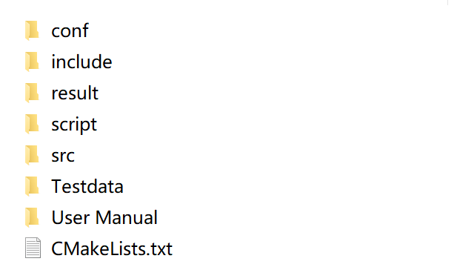

**Fig. 2** File list

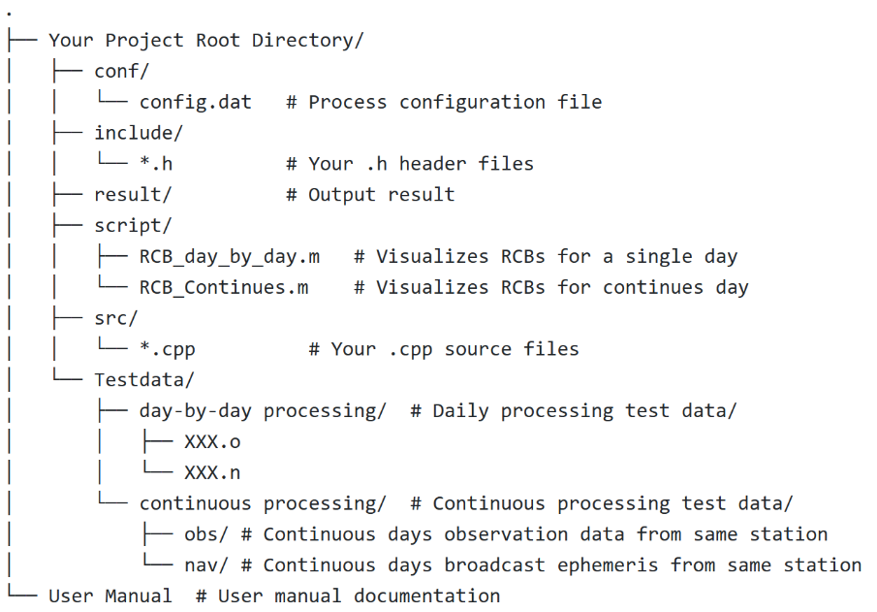

**Fig. 3** The structure of File

# 5 Configuration File (config.dat)

The configuration file mainly contains four parts:

1. Input file configuration
2. Output file configuration
3. Processing strategies configuration
4. Station names

It is noted that ‘#’ represents the function of annotation in the configuration file. Users can choose different process options according their realistic needs. Users configure the input and output paths according to their specific requirements.

## 5.1 Input file configuration

Users need to set an absolute path.

* OBS_PATH: single station observation file path
* NAV_PATH: broadcast ephemeris file path



**Fig. 4** Input file configuration

## 5.2 Output file configuration

Users need to set an absolute path.

* OUT_PRO: Dir for process information file; file name is auto-generated.
* OUT_PATH: Dir for result file; file name is auto-generated.
* OUT_LOG: Dir for sat log file; file name is auto-generated. record the satellite elimination records

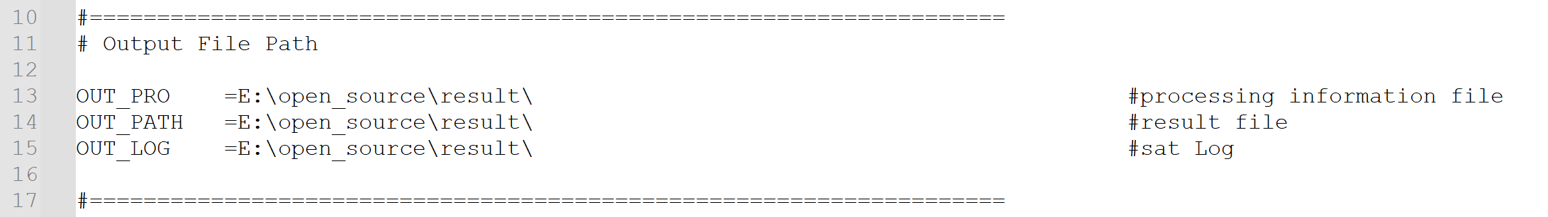

**Fig. 5** Output file configuration

**Note:** The slash direction varies by operating system

* **Windows:** Use backslashes (\). Example: C:\Users\username\input\data.obs
* **Linux:** Use forward slashes (/). Example: C:/Users/username/input/data.obs

## 5.3 Processing strategies configuration

* UseBDS2: Distinguishes between BDS-2 and BDS-3 satellites due to differing RCB variations trends. 0→Uses only BDS-3 satellite data 1→Uses only BDS-2 satellite data
* Frequency: Number of frequency bands to process
* Exclsats: Satellites to be manually excluded
* System: GNSS systems to be processed

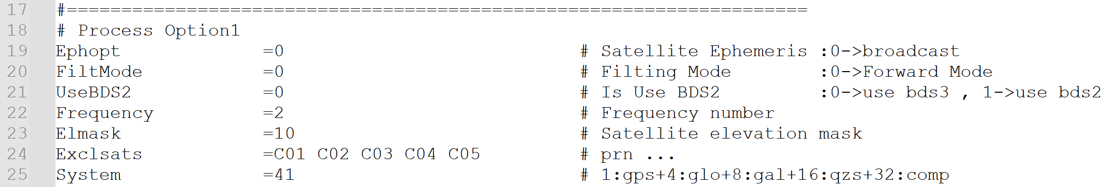

**Fig. 6** Processing options 1 configuration

* **Continue:** day-by-day means processes data one day at a time, used to analyze RCB variations within a single day; continuous processing means processes multiple consecutive days together, used to analyze RCB variations across several days.
* OBS_DIR: Observation data folder for multiple consecutive days
* NAV_DIR: Broadcast ephemeris folder for multiple consecutive days



**Fig. 7** Processing options 2 configuration

## 5.4 Station Information

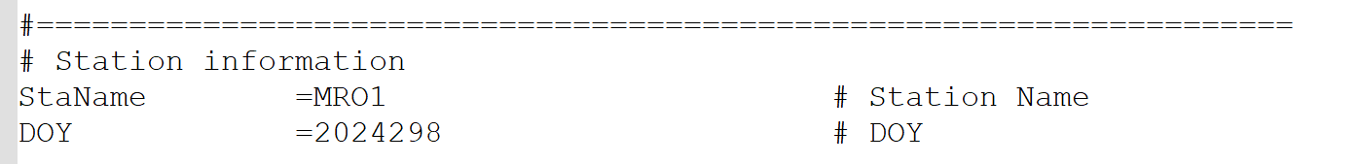

**Fig. 8** Station information configuration

# 6 Compile and Run

## 6.1 Compile

### 6.1.1 Windows

Ensure that the complete compilation tool and CMAKE (version 3.10 or higher) is installed.

* Extract the files downloaded from GitHub

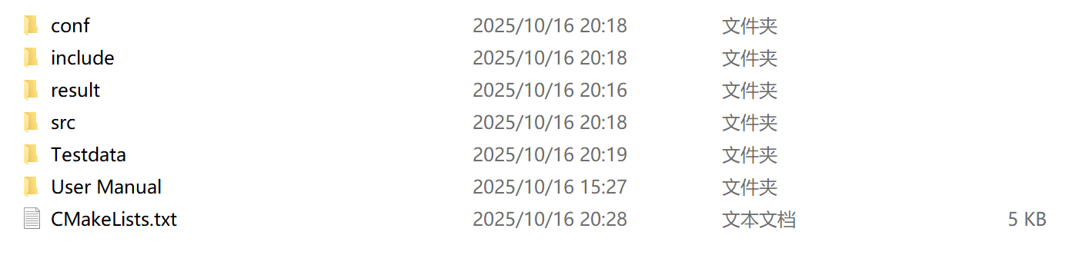

**Fig. 9** The extracted files

* Search "x64 Native Tools Command Prompt for VS 2022"

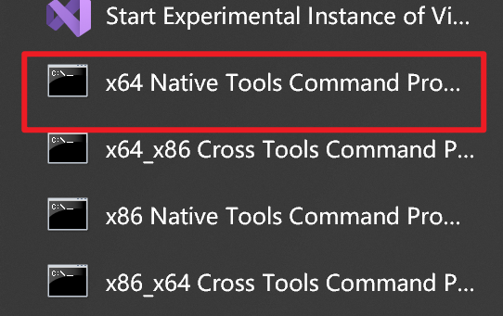

**Fig. 10** Open Command Prompt

* Navigate to Project Directory and Compile. Execute these commands in sequence

① cd your_project_path ②mkdir build ③cmake -B build ④cmake --build build

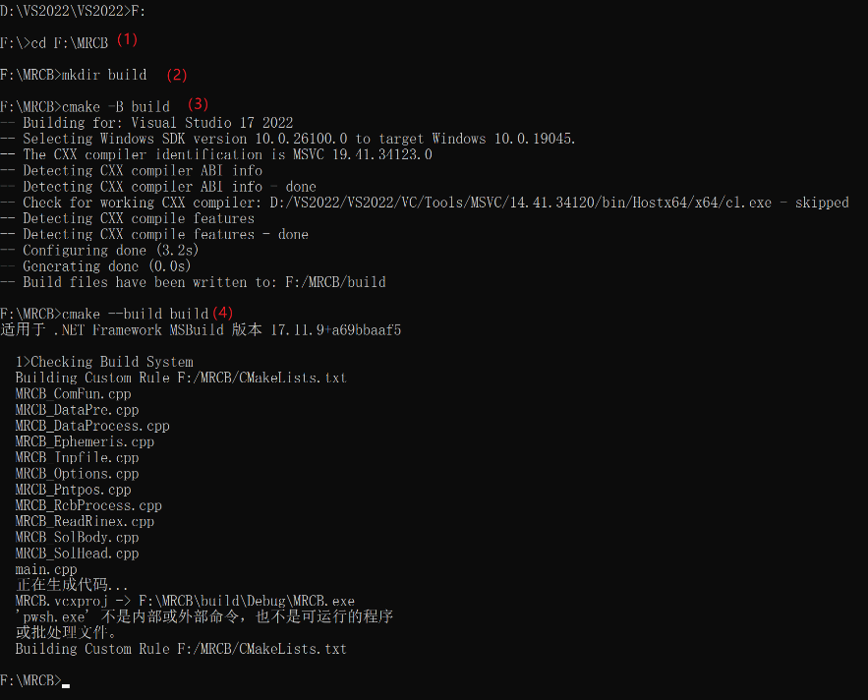

**Fig. 11** Finish compile under Windows

### Linux

Ensure that the complete compilation tool and CMAKE (version 3.10 or higher) is installed. Execute these commands in sequence: ① cd your_project_path ② mkdir build ③ cd build ④ cmake .. ⑤ make

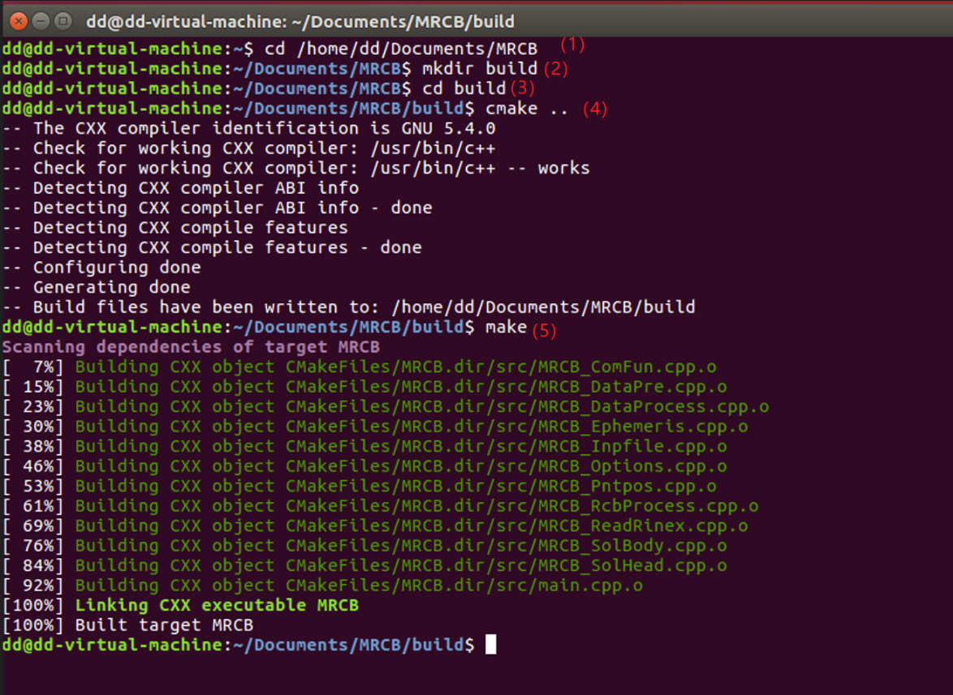

**Fig. 12** Finish compile under Linux

## 6.2 Run

Using Windows as an example, we will introduce the operational process with two examples: the day-by-day process and continuous processing

### 6.2.1 day-by-day process

（1）Compile code

Reference the **section 6.1.**

（2）Data Preparation

In the **config.dat** file, configure the parameters by setting the input and output paths according to your specific needs and file locations.

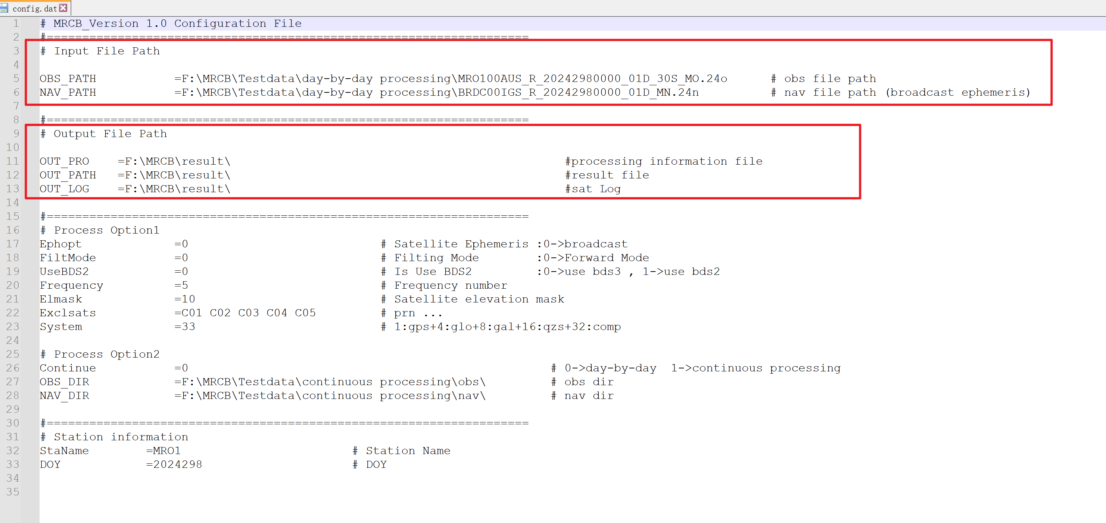

**Fig. 13** Paths Requiring Configuration

（3）Run code

Recommend running in the command line: ① cd ./build/Debug ② MRCB.exe

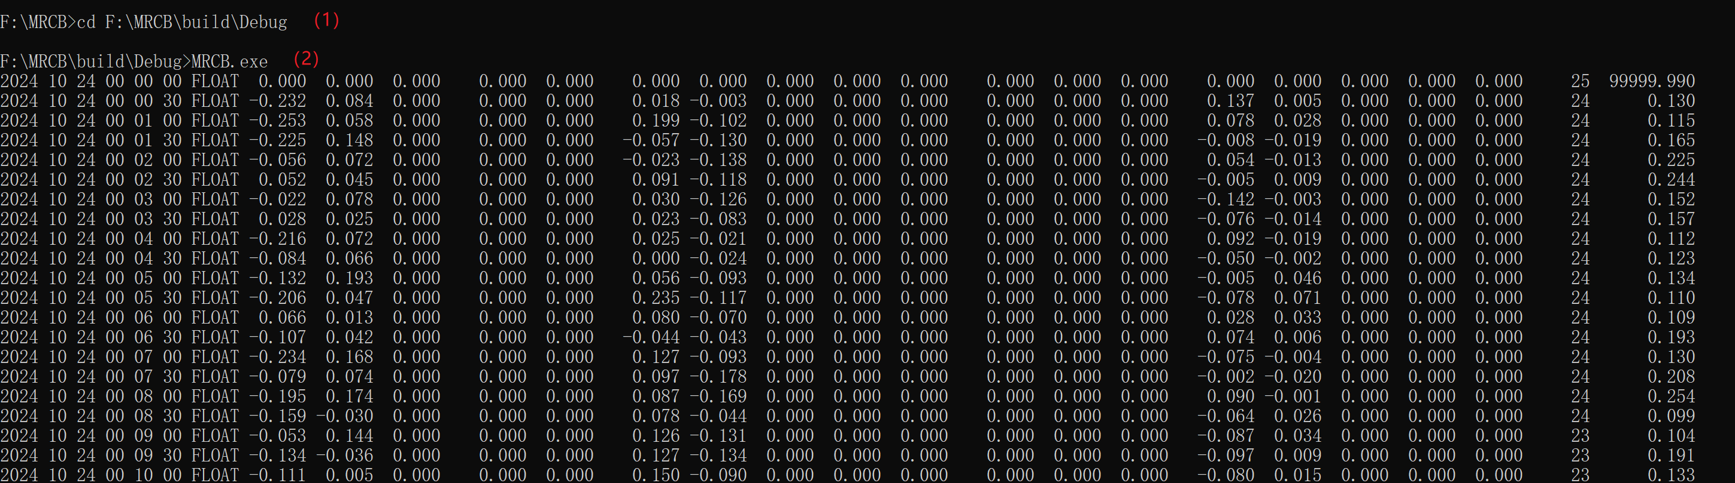

**Fig. 14** Runtime Display

（4）Visualization

Two simple visualization scripts are located in the **.\script** directory and require MATLAB (version R2020b or higher) to run.

* RCB_day_by_day.m: Visualizes RCBs for a single day. Simply configure the file paths and specify the frequencies and systems to visualize.

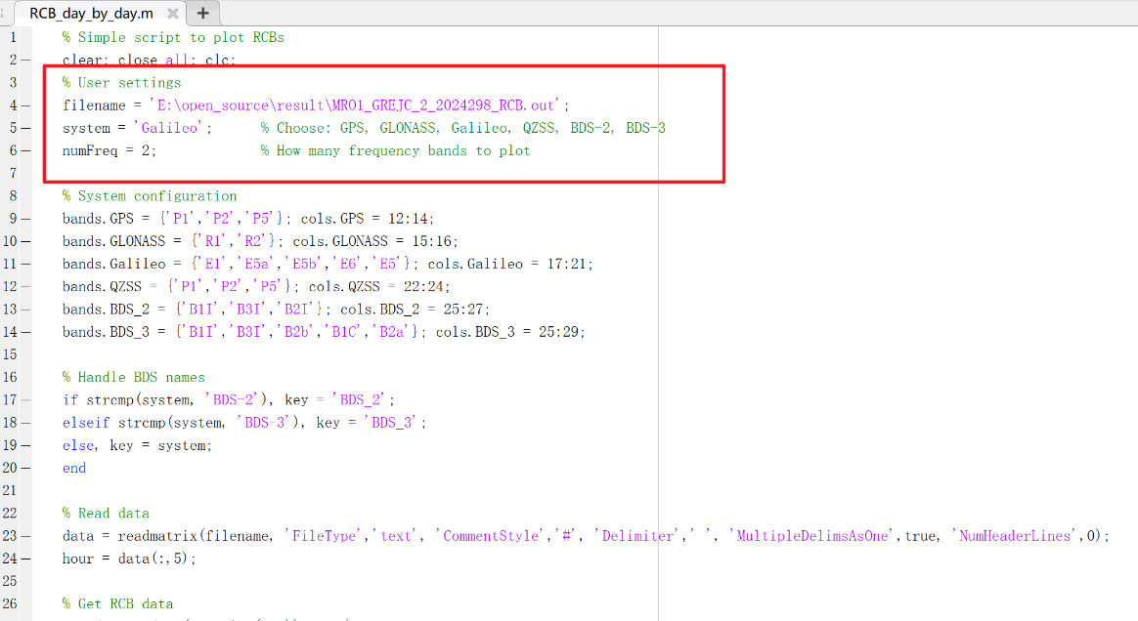

**Fig. 15** Visualizes RCBs for a single day

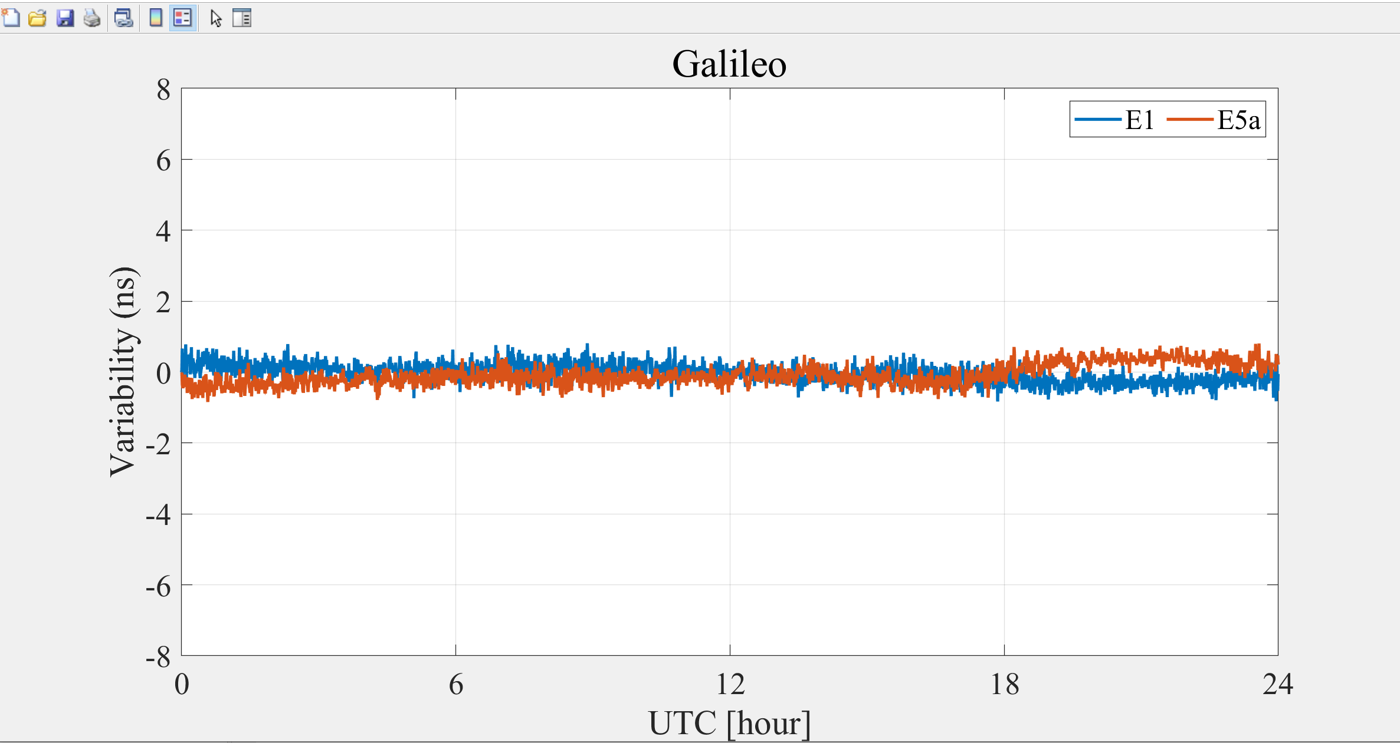

**Fig. 16** Visualization Results

### 6.2.2 continuous processing

（1）Compile code

Reference the **section 6.1.**

（2）Data Preparation

In the **config.dat** file, configure the parameters by setting the input and output paths according to your specific needs and file locations. When use **continuous processing,** the following parameters do not need to be set and can be left as default: OBS_PATH, NAV_PATH, DOY.

Configure the following input and output parameters:

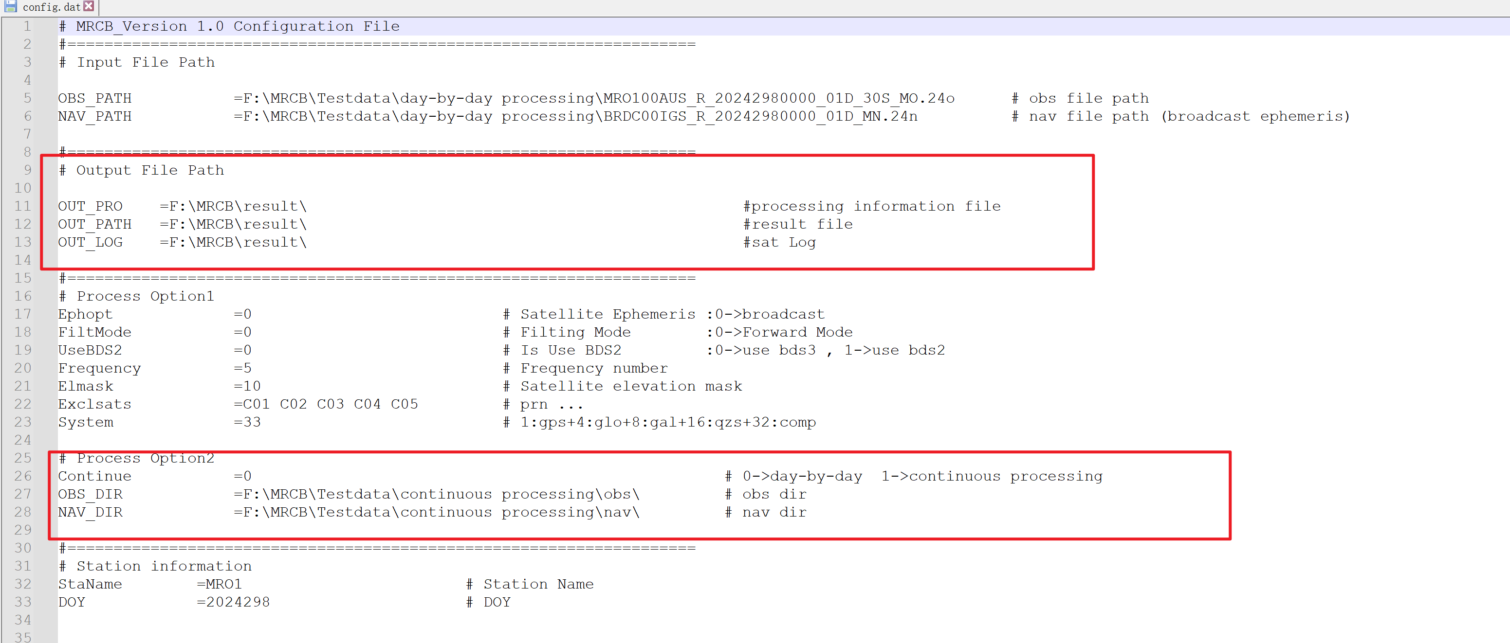

**Fig. 17** Paths Requiring Configuration

**Note:** When using the Continuous processing mode, ensure the observation files in the OBS_DIR directory and navigation files in the NAV_DIR directory follow consistent naming and maintain strict day-to-day correspondence. This ensures the continuous processor can correctly associate observation and navigation data across multiple consecutive days.

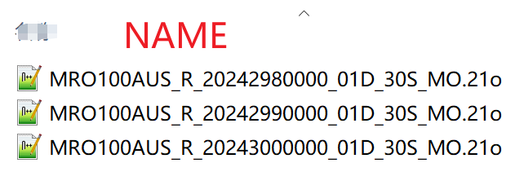 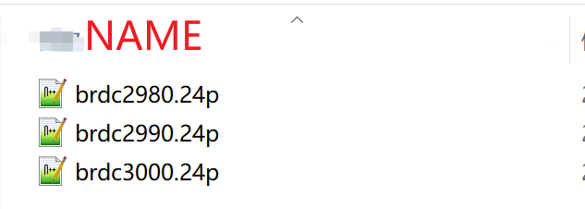

**Fig. 18** Example of Correct File Organization

（3）Run code

Recommend running in the command line.

（4）Visualization

* RCB_Continues.m: Visualizes RCBs for continues day. Simply configure the file paths and specify the frequencies and systems to visualize.

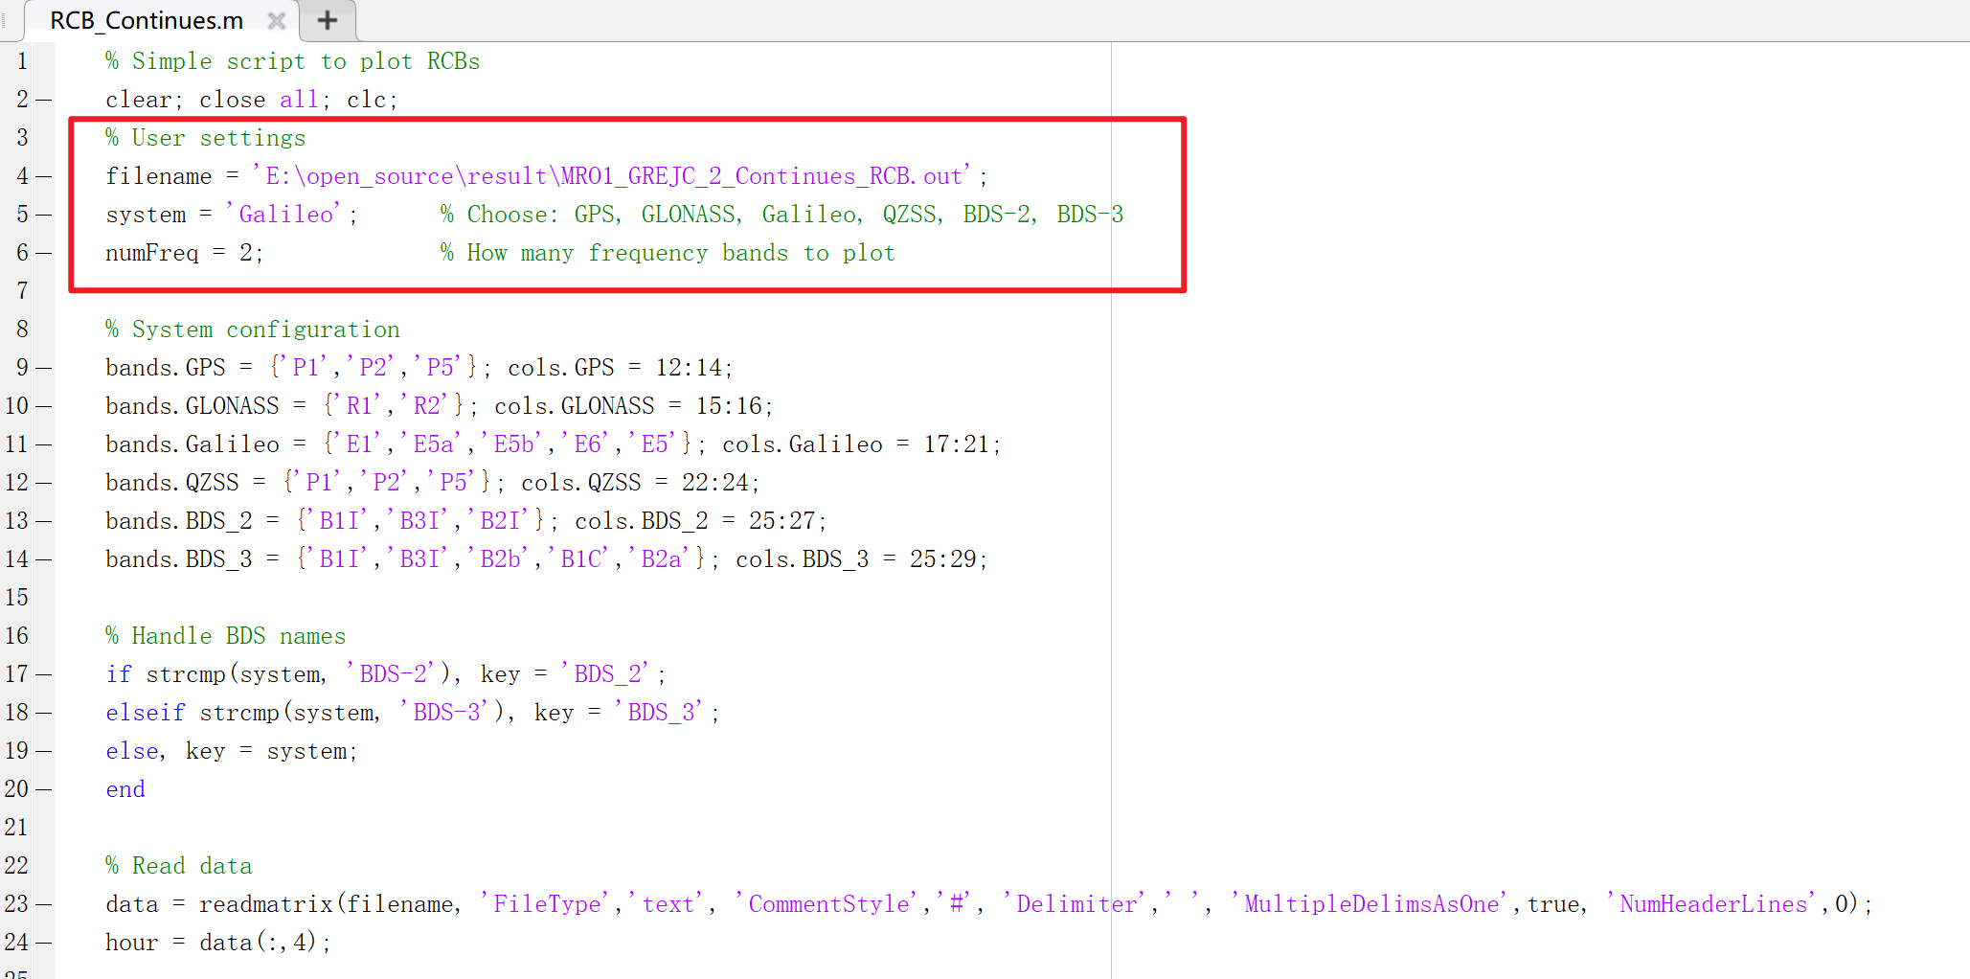

**Fig. 19** Visualizes RCBs for continues day

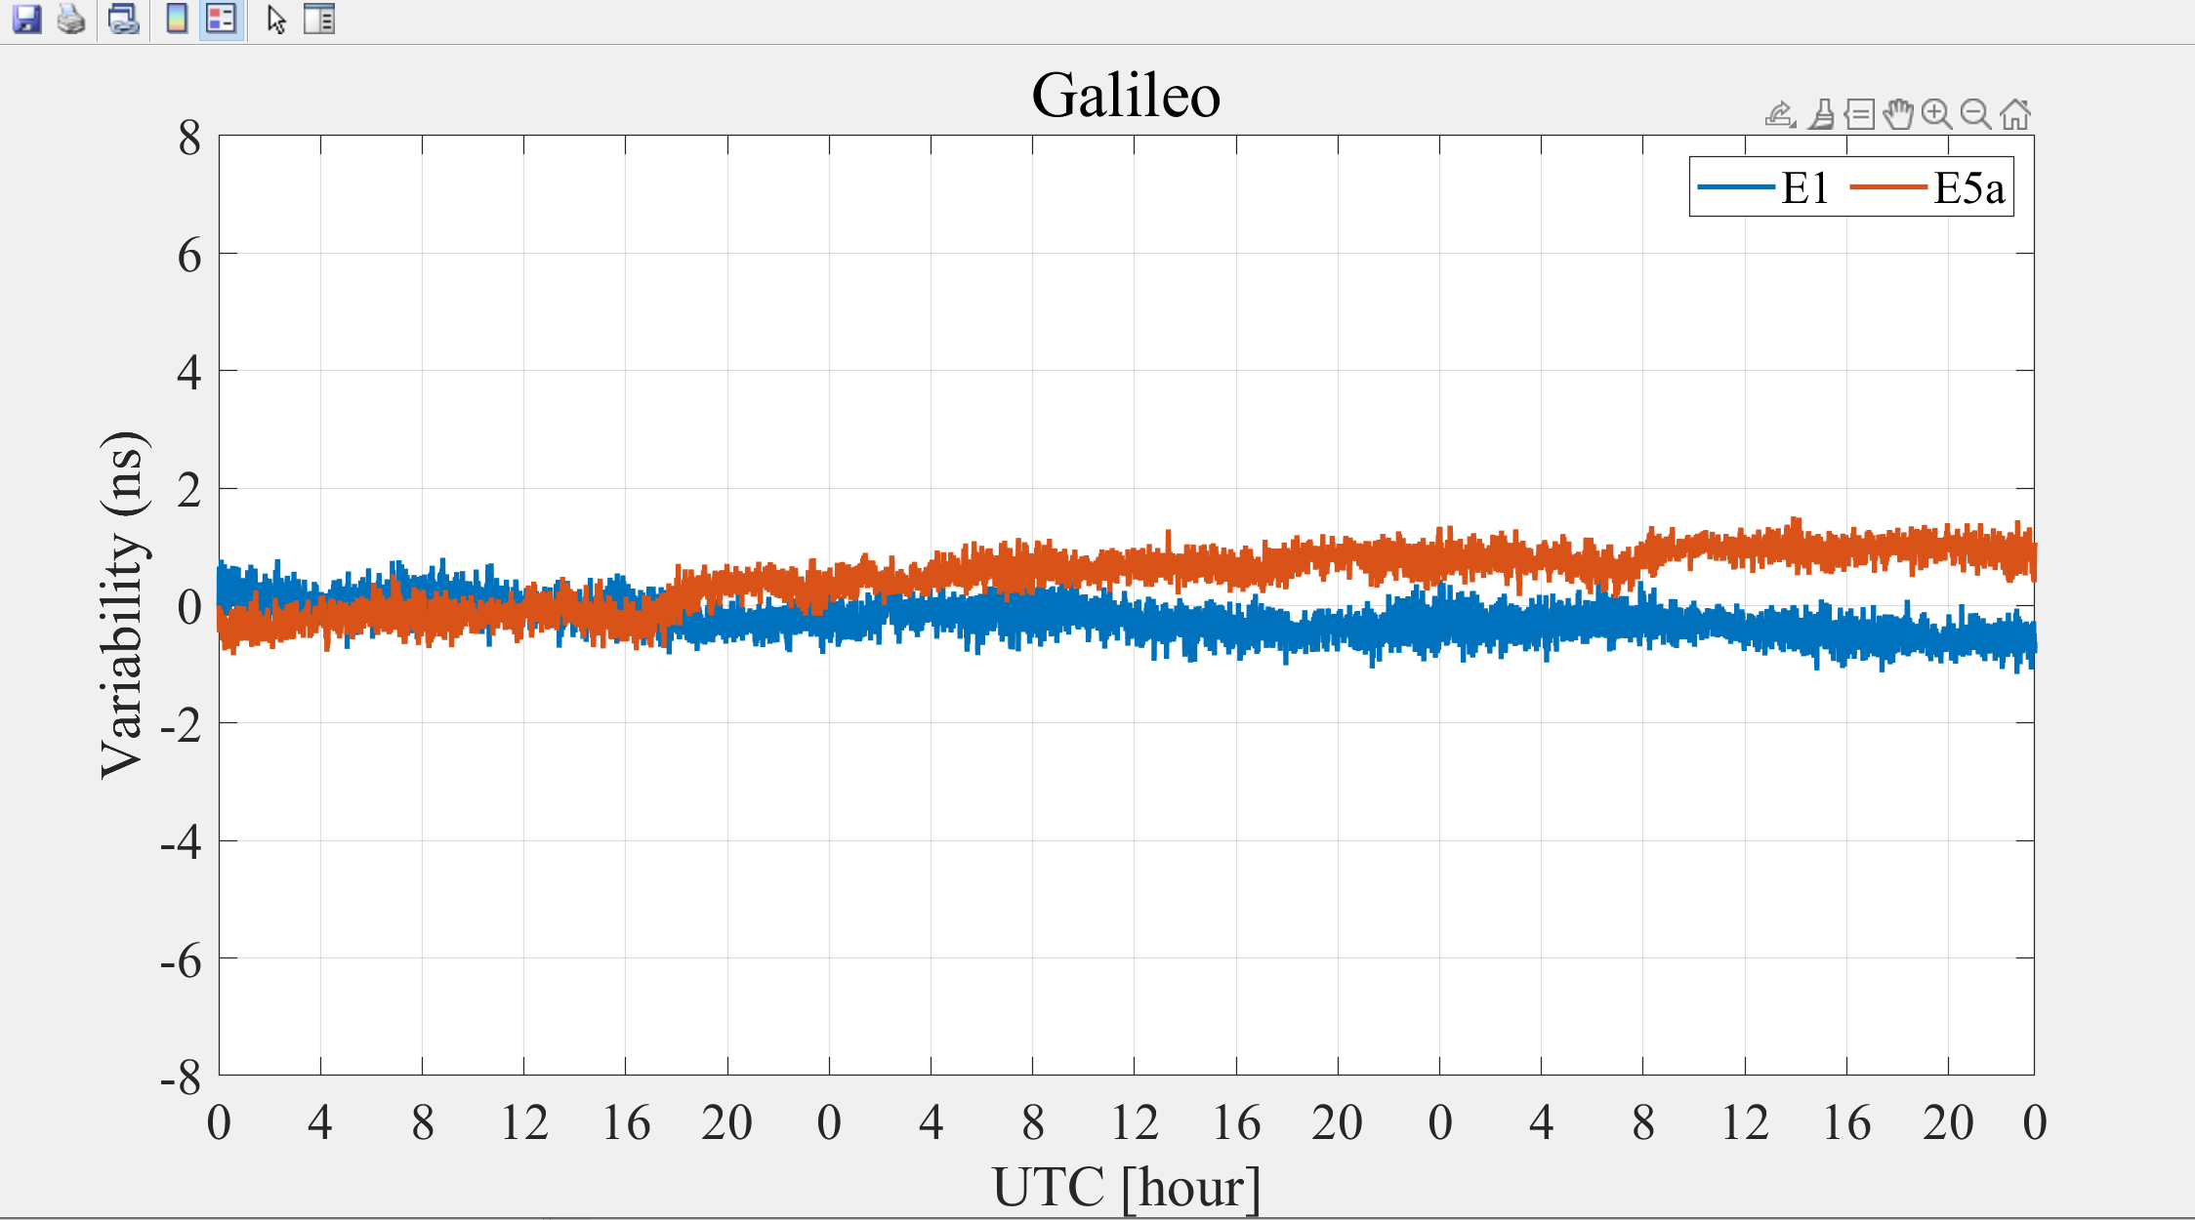

**Fig. 20** Visualization Results

### 6.2.3 Linux Run

If you want run on the Linux system.

Execute these commands in sequence: ./MRCB

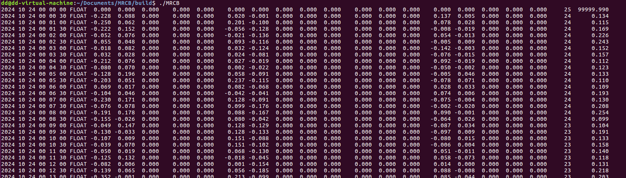

**Fig. 21** Run on Linux

# 7 Output file format description

## 7.1 Result File

Name: XXXX_GEC_2_YYYYDOY_RCB.out

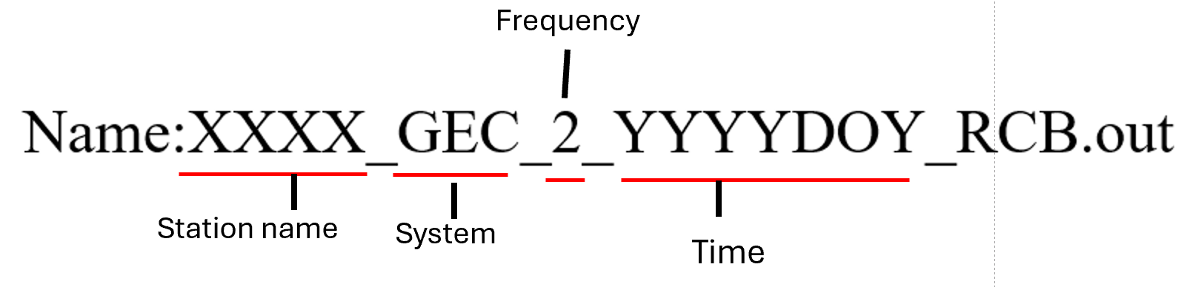

**Fig. 22** Structure of output file name

**Table 3** Result output file format description

|  |  |  |  |
| --- | --- | --- | --- |
| Items |  | Value Type | Range |
| Epoch Time (GPST) | Year  Month  Day  Hour  Minute  Second | char  char  char  char  char  char | 1-4  6-7  9-10  12-13  15-16  18-22 |
| Receiver Position (SPP) | X (m)  Y (m)  Z (m) | double  double  double | 25-37  41-52  55-67 |
| Number of valid satellites |  | int | 71-72 |
| GDOP |  | double | 76-81 |
| GPS Time-varying RCB | P1  P2  P5 | double  double  double | 86-91  95-100  104-109 |
| GLONASS Time-varying RCB | R1  R2 | double  double | 115-120  124-130 |
| Galileo Time-varying RCB | E1  E5a  E5b  E6  E5 | double  double  double  double  double | 136-141  146-151  157-162  167-172  177-182 |
| QZSS Time-varying RCB | P1  P2  P5 | double  double  double | 190-195  199-204  208-213 |
| BDS-3 Time-varying RCB | B1I  B3I  B2b  B1C  B2a | double  double  double  double  double | 218-223  230-235  242-248  255-260  266-271 |
| BDS-2 Time-varying RCB | B1I  B3I  B2I | double  double  double | 218-223  230-235  242-248 |

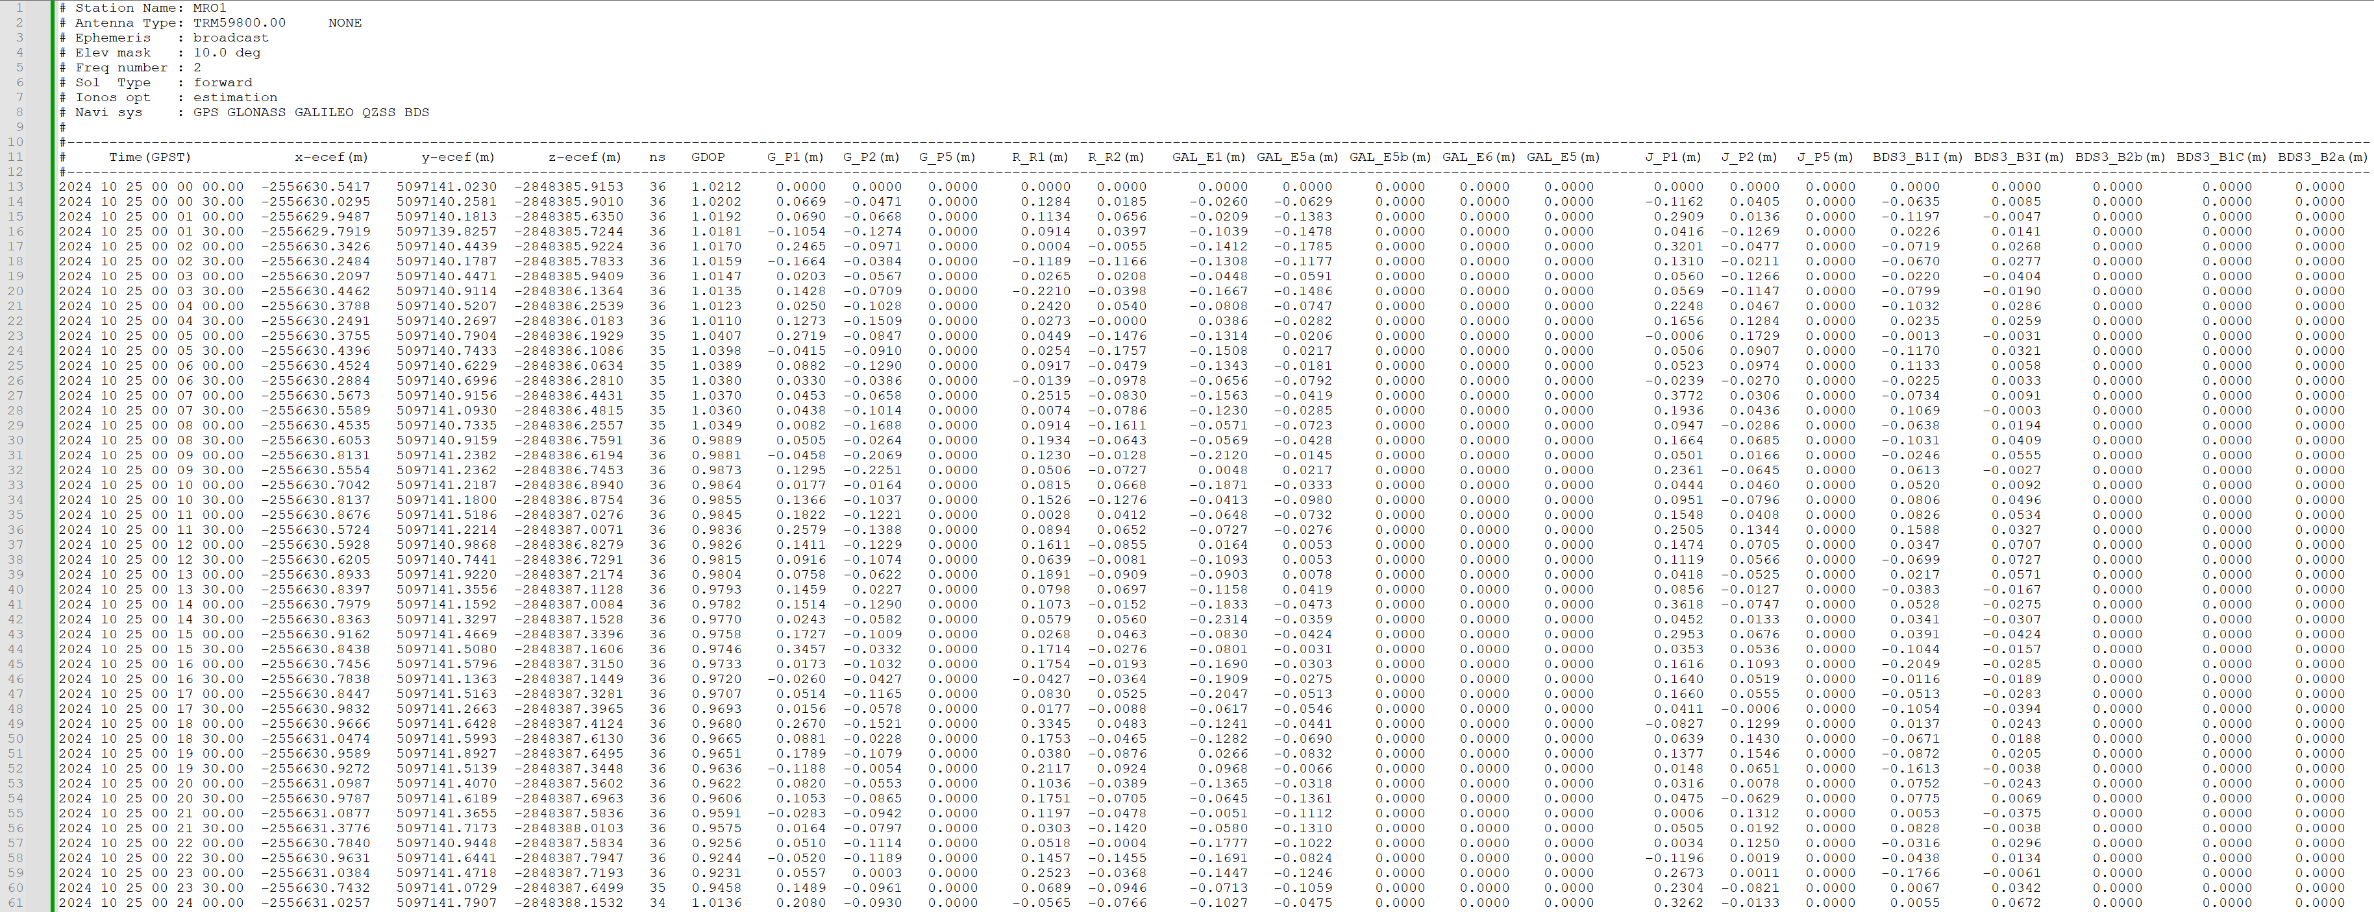

**Fig. 23** Screenshot of RCBs result file

## 7.2 Process Information File

Name: XXXX_GEC_2_YYYYDOY_Inf.pro

**Table 4** Process information file description

|  |  |  |  |
| --- | --- | --- | --- |
| Items |  | Value Type | Range |
| Satellite Sys. & PRN |  | int | 1-4 |
| Satellite Positions | X (m)  Y (m)  Z (m) | double  double  double | 6-13  23-35  38-51 |
| Satellite Clock Offset | (m) | double | 56-67 |
| Ion Delays | (m) | double | 75-83 |
| Ambiguity | F1 (cycle)  F2 (cycle)  F3 (cycle)  F4 (cycle)  F5 (cycle) | double  double  double  double  double | 91-99  107-115  124-131  140-147  156-163 |
| Satellite Elevation and Azimuth | Elevation (°)  Azimuth (°) | double  double | 173-179  188-195 |
| post-fit carrier phase residuals | F1 (m)  F2 (m)  F3 (m)  F4 (m)  F5 (m) | double  double  double  double  double | 199-211  215-227  231-243  247-259  263-275 |
| post-fit code residuals | F1 (m)  F2 (m)  F3 (m)  F4 (m)  F5 (m) | double  double  double  double  double | 280-292  296-308  312-324  328-340  344-356 |
| SCB | F3 (m)  F4 (m)  F5 (m) | double  double  double | 365-372  381-388  397-404 |

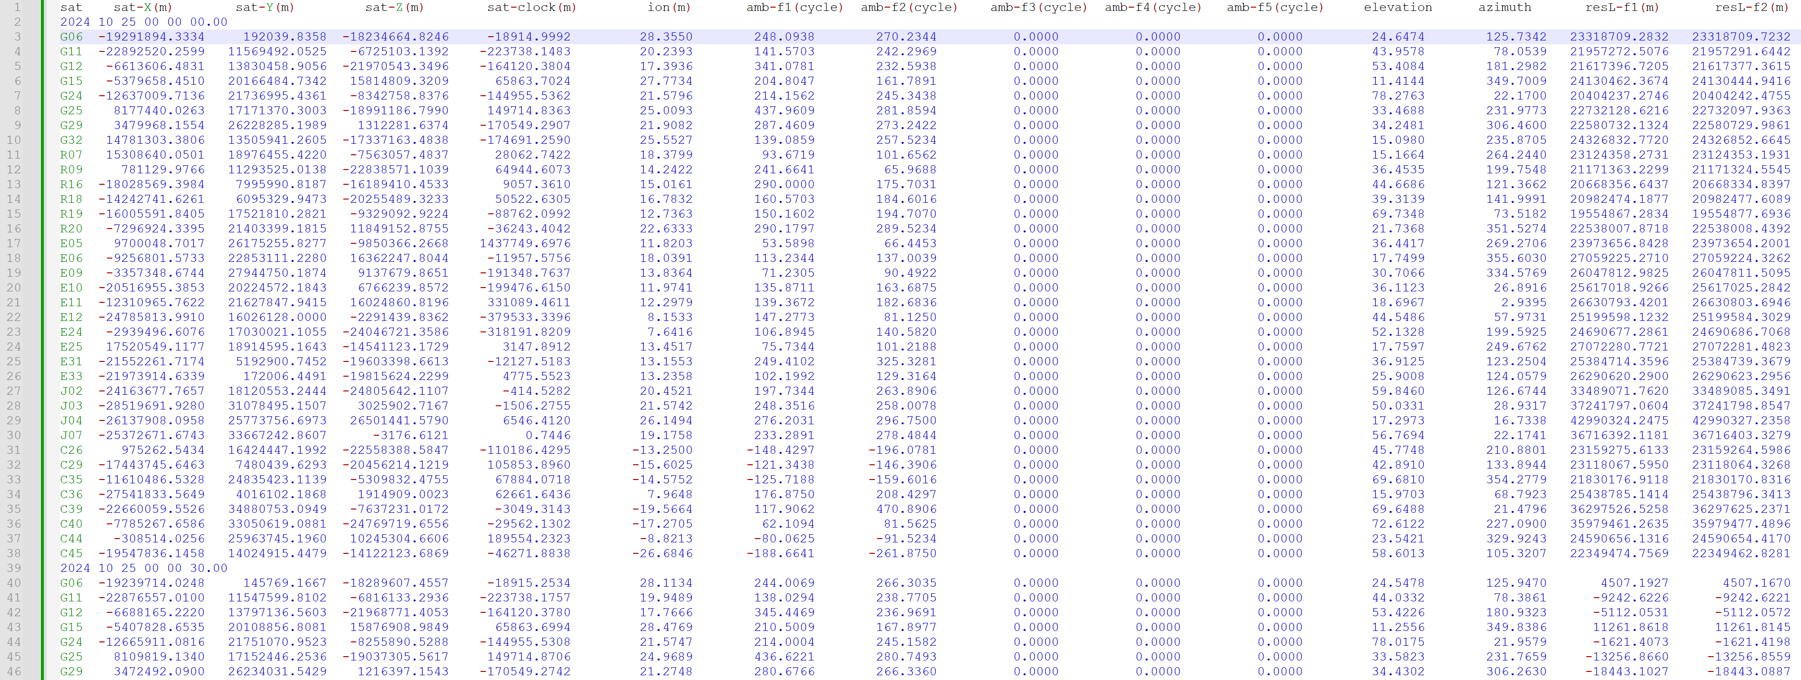

**Fig. 24** Screenshot of Process Information file

## 7.3 Log file

Name: XXXX_GEC_2_YYYYDOY_Sat.log

The log file mainly contains the record of satellite eliminations.

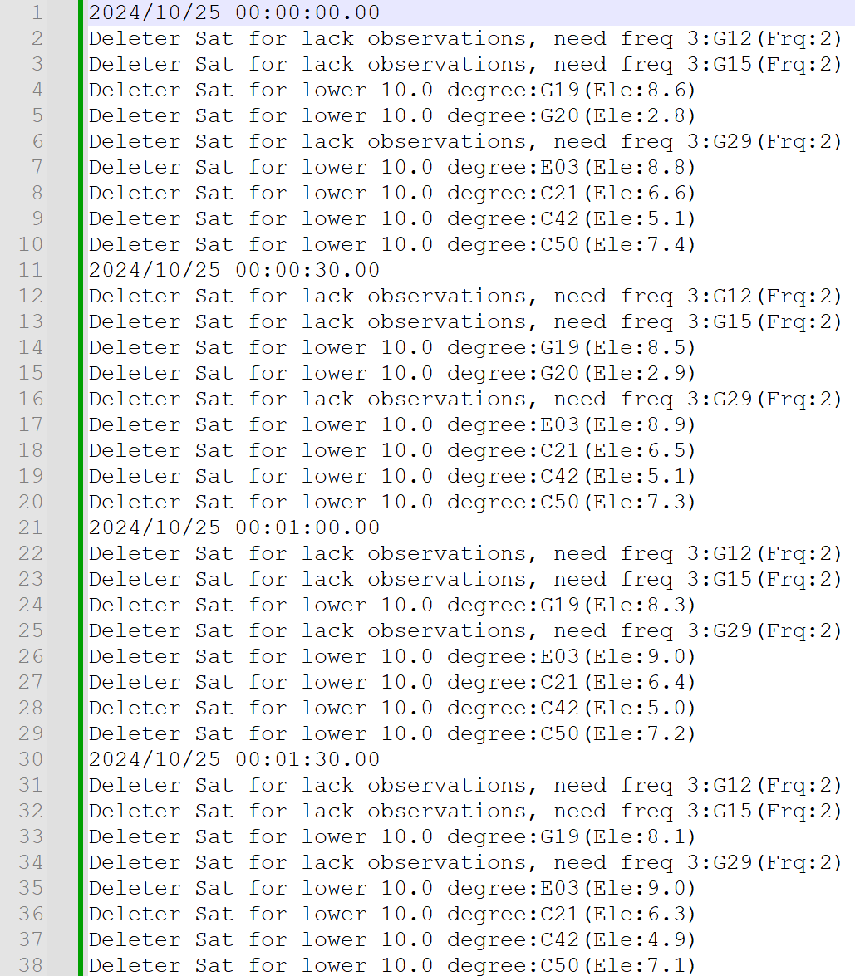

**Fig. 25** Screenshot of Log file

When use Continues processing, the file name become:

XXXX_GEC_2_Continues_RCB.out

XXXX_GEC_2_Continues_Inf.pro

XXXX_GEC_2_Continues_Sat.log

## 7.4 Execution Interface

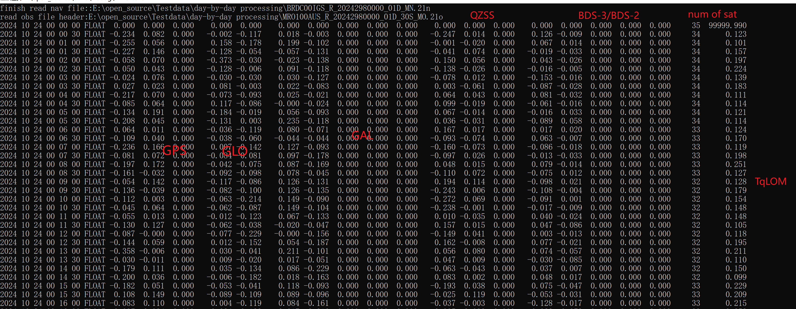

**Fig. 26** Runtime Display RCBs

# Appendix

(1) CDMA RCB Function Model

We commence with the undifferenced and uncombined GNSS observation equations, which are written as (Teunissen and Montenbruck, 2017)

$$\begin{aligned}\left\{\begin{aligned}&{E[P}_{r,f}^{s}(i)]=ρ_{r}^{s}(i)+μ_{f}⋅I_{r,1}^{s}(i)+b_{r,f}-b_{f}^{s} \\ &{E[L}_{r,f}^{s}(i)]=ρ_{r}^{s}(i)-μ_{f}⋅I_{r,1}^{s}(i)+λ_{f}α_{r,f}^{s}\end{aligned}\right.\#\left(1\right)\end{aligned}$$

where $E(.)$ denotes the expectation operator. $P_{r,f}^{s}$ and $L_{r,f}^{s}$ represent observed-minus-calculated code and phase observations of a satellite $s$ tracked by a receiver $r$ on the frequency $f$ at the epoch $i$, respectively. The frequency-independent parameters in this, including the range, receiver clock offsets, satellite clock offsets, and tropospheric delays, were combined into a single parameter $ρ_{r}^{s}(i)$. the first-order slant ionospheric delay $I_{r,1}^{s}(i)$ on the first frequency linked to other frequencies by the coefficient $μ_{f}=λ_{f}^{2}/λ_{1}^{2}$ with $λ_{f}$ being the wavelength, the RCB $b_{r,f}$ and its satellite counterpart $b_{f}^{s}$, and the float ambiguity $α_{r,f}^{s}=N_{r,f}^{s}+δ_{r,f}-δ_{f}^{s}$ containing the receiver phase bias (RPB) $δ_{r,f}$, the satellite phase bias $δ_{f}^{s}$, and the integer ambiguity $N_{r,f}^{s}$. We consider the parameters with an epoch index $i$ as time-varying quantities and assume the parameters without the epoch index to be time constant.

Departing from the time-constant assumption of the RCB, we consider it a time-varying parameter and rewrite Eq. (1) as

$$\begin{aligned}\left\{\begin{aligned}&{E[P}_{r,f}^{s}(i)]=ρ_{r}^{s}(i)+μ_{f}⋅I_{r,1}^{s}(i)+b_{r,f}(1)+{\tilde{b}}_{r,f}(i)-b_{f}^{s} \\ &{E[L}_{r,f}^{s}(i)]=ρ_{r}^{s}(i)-μ_{f}⋅I_{r,1}^{s}(i)+λ_{f}α_{r,f}^{s}\end{aligned}\right.\#\left(2\right)\end{aligned}$$

where

$$\begin{aligned}{\tilde{b}}_{r,f}\left(i\right)=b_{r,f}\left(i\right)-b_{r,f}\left(1\right)\#\left(3\right)\end{aligned}$$

denotes the time-differenced receiver bias between epoch $i$ and the first epoch, but parameters in Eq. (2) are not uniquely estimable due to the rank deficient problem. For this issue, we turn to the S-system theory (Baarda, 1973; Teunissen, 1985), which constraints a minimum set of parameters and formulates a full-rank model estimating the linear functionals of the original parameters. To make it clear, we first decompose the receiver and satellite code biases on the first two frequencies as

$$\begin{aligned}{\left(.\right)}_{r,f}={\left(.\right)}_{r,IF}+{μ_{f}\left(.\right)}_{r,GF}\#\left(4\right)\end{aligned}$$

where the geometry-free combination of a frequency-dependent quantity is defined as

$$\begin{aligned}{\left(.\right)}_{GF}=\frac{1}{μ_{2}-μ_{1}}\left[{\left(.\right)}_{2}-{\left(.\right)}_{1}\right]\#\left(5\right)\end{aligned}$$

Inserting Eq. (4) into the code observations equation in Eq. (2) yields

$$\begin{aligned}\left\{\begin{aligned}&{E[P}_{r,f}^{s}(i)]=ρ_{r}^{s}(i)+μ_{f}I_{r,1}^{s}(i)+b_{r,IF}(1)+{μ_{f}b}_{r,IF}(1)-μ_{f}b_{r,GF}^{s}+{\tilde{b}}_{r,f}(i)+{\overline{b}}_{r,f>2}^{s} \\ &{E[L}_{r,f}^{s}(i)]=ρ_{r}^{s}(i)-μ_{f}I_{r,1}^{s}(i)+λ_{f}α_{r,f}^{s}\end{aligned}\right.\#\left(6\right)\end{aligned}$$

where

$${\overline{b}}_{r,f>2}^{s}=[b_{r,f}(1)-b_{r,IF}(1)-u_{f}⋅b_{r,GF}(1)]-(b_{,f}^{s}-u_{f}⋅b_{,GF}^{s})$$

denotes the combination of receiver and satellite code biases on the third frequency and above.The rank deficiency elimination for Eq. (6) becomes straightforward, as we can lump the parameters that have common coefficients:

$$\begin{aligned}{E[P}_{r,f}^{s}(i)]={\overline{ρ}}_{r}^{s}(i)+μ_{f}{\overline{I}}_{r,1}^{s}(i)+{\tilde{b}}_{r,f}(i)+{\overline{b}}_{r,f>2}^{s}\#\left(7\right)\end{aligned}$$

where

$$\begin{aligned}\left\{\begin{aligned}&{\overline{ρ}}_{r}^{s}(i)=ρ_{r}^{s}(i)+b_{r,IF}(1) \\ &{\overline{I}}_{r,1}^{s}(i)=I_{r,1}^{s}(i)+b_{r,GF}(1)-b_{,GF}^{s}\end{aligned}\right.\#\left(8\right)\end{aligned}$$

denote the frequency-independent parameter and ionospheric delays, respectively. When dealing with the phase observations in Eq. (2), we first replace ${ ρ}_{r}^{s}(i)$ and $I_{r,1}^{s}(i)$ with ${\overline{ρ}}_{r}^{s}(i)$ and ${\overline{I}}_{r,1}^{s}(i)$, resulting in additional code biases. By lumping these biases with ambiguities, we obtain the full-rank observation equations as

$$\begin{aligned}\left\{\begin{aligned}&{E[P}_{r,f}^{s}(i)]={\overline{ρ}}_{r}^{s}(i)+μ_{f}{\overline{I}}_{r,1}^{s}(i)+{\tilde{b}}_{r,f}(i)+{\overline{b}}_{r,f>2}^{s} \\ &{E[L}_{r,f}^{s}(i)]={\overline{ρ}}_{r}^{s}(i)-μ_{f}{\overline{I}}_{r,1}^{s}(i)+λ_{f}{\overline{α}}_{r,f}^{s}\end{aligned}\right.\#\left(9\right)\end{aligned}$$

where

$$\begin{aligned}{\overline{α}}_{r,f}^{s}=α_{r,f}^{s}+\left[b_{,IF}^{s}-b_{r,IF}\left(1\right)\right]/λ_{f}-μ_{f}⋅\left[b_{,GF}^{s}-b_{r,GF}\left(1\right)\right]/λ_{f}\#\left(10\right)\end{aligned}$$

denote the estimable parameters contain the RCB at the first epoch.

(2) FDMA RCB Function Model

GLONASS raw code and carrier phase observation equations as (Teunissen, 2019)

$$\begin{aligned}\left\{\begin{aligned}&{E[P}_{r,f}^{s}(i)]=ρ_{r}^{s}(i)+μ_{f}^{s}⋅I_{r,1}^{s}(i)+b_{r,f}-b_{f}^{s}+k^{s}Δb_{r,f} \\ &{E[L}_{r,f}^{s}(i)]=ρ_{r}^{s}(i)-μ_{f}^{s}⋅I_{r,1}^{s}(i)+λ_{f}^{s}(α_{r,f}^{s}+k^{s}Δδ_{r,f})\end{aligned}\right.\#\left(11\right)\end{aligned}$$

different from CDMA observation equations, there exist receiver code and phase biases that are linear functions of the satellite frequency channel number, $Δb_{r,f}$ and $Δδ_{r,f}$, respectively. The meanings of the remaining parameters are the same as in Eq. (1).

In particular, GLONASS satellites have different wavelengths, expressed as $λ_{f}^{s}$. Furthermore, the coefficients of the ionospheric parameters $μ_{f}^{s}$ are also satellite-dependent. To simplify the coefficients of the ionospheric parameters, they are defined based on the frequency of each GLONASS R1 and R2 satellite as follows:

$$\begin{aligned}F_{f}^{s}=F_{f}^{0}+k^{s}ΔF_{f}\#\left(12\right)\end{aligned}$$

where $F_{f}^{0}$ is the center frequency, $ΔF_{f}$ is the frequency offset, $ΔF_{1}=9/16$, $ΔF_{2}=7/16$, $k^{s}$ is the frequency channel number of satellite $s$, and they satisfy $|k^{s}|≤13$, $ΔF_{1}/F_{1}^{0}=1/2848$, $ΔF_{2}/F_{2}^{0}=1/2848$. Therefore, the wavelength $λ_{f}^{s}$ can be expressed as:

$$\begin{aligned}λ_{f}^{s}=\frac{c}{F_{f}^{0}+k^{s}ΔF_{f}}=\frac{λ_{f}^{0}}{1+\frac{k^{s}ΔF_{f}}{F_{f}^{0}}}=\frac{2848λ_{f}^{0}}{2848+k^{s}}\#\left(13\right)\end{aligned}$$

where $λ_{f}^{0}=c/F_{f}^{0}$ is the wavelength corresponding to the center frequency. According to Equation (13), the coefficients of the ionospheric parameters can be written as:

$$\begin{aligned}μ_{f}^{s}={\left(\frac{λ_{f}^{s}}{λ_{1}^{s}}\right)}^{2}={\left(\frac{2848λ_{f}^{0}}{2848+k^{s}}∙\frac{2848+k^{s}}{2848λ_{1}^{0}}\right)}^{2}=μ_{f}\#\left(14\right)\end{aligned}$$

Therefore, Equation (11) can be simplified as:

$$\begin{aligned}\left\{\begin{aligned}&{E[P}_{r,f}^{s}(i)]=ρ_{r}^{s}(i)+μ_{f}⋅I_{r,1}^{s}(i)+b_{r,f}-b_{f}^{s}+k^{s}Δb_{r,f} \\ &{E[L}_{r,f}^{s}(i)]=ρ_{r}^{s}(i)-μ_{f}⋅I_{r,1}^{s}(i)+λ_{f}^{s}(α_{r,f}^{s}+k^{s}Δδ_{r,f})\end{aligned}\right.\#\left(15\right)\end{aligned}$$

Departing from the time-constant assumption of the RCB, we consider it a time-varying parameter and rewrite Eq. (14) as:

$$\begin{aligned}\left\{\begin{aligned}&{E[P}_{r,f}^{s}(i)]=ρ_{r}^{s}(i)+μ_{f}⋅I_{r,1}^{s}(i)+b_{r,f}(1)+{\tilde{b}}_{r,f}\left(i\right)-b_{f}^{s}+k^{s}Δb_{r,f}(1)+k^{s}Δ{\overline{b}}_{r,f}(i) \\ &{E[L}_{r,f}^{s}(i)]=ρ_{r}^{s}(i)-μ_{f}⋅I_{r,1}^{s}(i)+λ_{f}^{s}(α_{r,f}^{s}+k^{s}Δδ_{r,f})\end{aligned}\right.\#\left(16\right)\end{aligned}$$

where

$$\begin{aligned}\left\{\begin{aligned}&{\tilde{b}}_{r,f}\left(i\right)=b_{r,f}\left(i\right)-b_{r,f}\left(1\right) \\ &Δ{\overline{b}}_{r,f}(i)=Δb_{r,f}(i)-Δb_{r,f}(1)\end{aligned}\right.\#\left(17\right)\end{aligned}$$

Note that, apart from the IFBs, the structure of the GLONASS equations is entirely consistent with that of CDMA systems. Therefore, following the rank deficiency elimination procedure used for CDMA, the following equations are obtained:

$$\begin{aligned}\left\{\begin{aligned}&{E[P}_{r,f}^{s}(i)]={\overline{ρ}}_{r}^{s}(i)+μ_{f}{\overline{I}}_{r,1}^{s}(i)+{\tilde{b}}_{r,f}\left(i\right)+k^{s}Δ{\overline{b}}_{r,f}(i) \\ &{E[L}_{r,f}^{s}(i)]={\overline{ρ}}_{r}^{s}(i)-μ_{f}{\overline{I}}_{r,1}^{s}(i)+λ_{f}^{s}({\overline{α}}_{r,f}^{s}+k^{s}Δδ_{r,f})\end{aligned}\right.\#\left(18\right)\end{aligned}$$

where

$$\begin{aligned}\left\{\begin{aligned}&{\overline{ρ}}_{r}^{s}(i)=ρ_{r}^{s}(i)+b_{r,IF}(1)-b_{,IF}^{s}+k^{s}Δb_{r,IF}(1) \\ &{\tilde{I}}_{r,1}^{s}(i)=I_{r,1}^{s}(i)+b_{r,GF}(1)-b_{,GF}^{s}+k^{s}Δb_{r,GF}(1) \\ &{\overline{α}}_{r,f}^{s}=α_{r,f}^{s}+k^{s}Δδ_{r,f}+\frac{\left[b_{,IF}^{s}-b_{r,IF}\left(1\right)-k^{s}Δb_{r,IF}\left(1\right)\right]}{λ_{f}^{s}}-\frac{μ_{f}⋅\left[b_{,GF}^{s}-b_{r,GF}\left(1\right)-k^{s}Δb_{r,GF}\left(1\right)\right]}{λ_{f}^{s}}\end{aligned}\right.\#\end{aligned}$$

# Acknowledgement

We sincerely thank Mr. Tomoji Takasu, the author of RTKLIB software. His great work and open-source spirit help many researchers. Our software is built on the software framework of RTKLIB, and we are grateful to the whole RTKLIB community.

# Contact author

Any suggestions, corrections, and comments on MRCB are sincerely welcomed; please contact us. MRCB will be updated frequently, I hope numerous people can participate in the next update.

Email: dusx0829@163.com

Address: No. 340 Xudong Street, Wuhan City, Hubei Prov. China 430077

# References

1. Teunissen P. J. G., Montenbruck O (eds) (2017) Springer handbook of global navigation satellite systems. Springer International Publishing, Cham
2. Baarda W (1973) S-transformations and criterion matrices. Netherlands Geodetic Commission
3. Teunissen P. J. G. (1985) Zero order design: generalized inverses, adjustment, the datum problem and S-transformations. In: Optimization and design of geodetic networks. Springer Berlin Heidelberg, Berlin, Heidelberg, pp 11–55
4. Teunissen, P. J. G. (2019). A new glonass fdma model. GPS solutions, 23(4), 100.